**

**WE**

**LOCATION:**

Milton Keynes

**WORKING HOURS:**

Wednesday – Sunday x1

Monday, Tuesday, Friday, Saturday & Sunday x1

Monday – Thursday x1

**DAY RATE:**

£150 per day

**OTHER BENEFITS:**

£15 daily bonus

**CONTACT TYPE:**

Casual, 1 Month FTC

**REPORTING IN TO:**

Brand Ambassador Manager

Hair Stylist

**WE’RE LOOKING FOR**

**YOU**

**NEED**

**WE’RE LOOKING FOR EXPERIENCED HAIR & BEAUTY STYLISTS**

As our Hair Stylist, you’ll play a key role in connecting the latest Shark Hair & Beauty products with our valued customers. You’ll play a crucial role in creating unforgettable brand experiences, showcasing the latest features and functionalities through styling customers hair through pre booked appointments. You’ll bring excitement and enjoyment into the customer experience, leveraging your engaging personality to influence purchase decisions and build brand loyalty.

If you’re an experienced hair stylist, with an active interest in beauty & personal wellness, passionate about showcasing the latest tech, this role is for you!

**TO MAKE A REAL DIFFERENCE IN THESE AREAS**

**HAIR STYLING**

* Last minute invite? In between wash days, you will pep up customer hair styles by using Sharks volumizing hot brush. Suitable for all hair types, we create root-lifting volume and shape for a full-body, back-to-gorgeous finish
* For a speedy high shine finish our rapid gloss finisher creates a sleek, smooth finish

on curly and coily hair or straight and wavy hair. Without causing heat damage,

Sharks Coanda technology creates frizz-free looks for super sleek results. Please

come with towel-dried damp hair.

* For effortless looking girly-curls, bouncy blow dries, relaxed beach waves or for

straightening out annoying kinks, this service will elevate your look using our

Coanda technology to prevent heat damage. Please come with towel dried damp

hair

**BRAND AWARENESS**

* Be the face of the brand, capturing the attention of consumers with your infectious energy and enthusiasm. Establish meaningful connections with customers, creating a positive and memorable brand experience
* Deliver captivating and informative product demonstrations
* Create memorable demonstrations and bring the products to life
* Ensure customers gain a deep understanding and appreciation for our products
* Working as a team to meet and exceed targets

**PRODUCT EXPERTISE**

* Become a Shark Hair & Beauty product expert! Know the product range inside out with the ability to upsell, educate customers on features and benefits of the products ensuring they leave with a deep appreciation of the brand
* Showcase features and functionalities of our latest products through hands-on experiences
* Stay up to date with the latest industry trends

**CONTRIBUTE TO A FUN ATMOSPHERE**

* Bring a sense of excitement and enjoyment into the customer experience
* Create a fun and welcoming atmosphere during product demonstrations, making the interaction not just informative but also enjoyable
* Your energy and enthusiasm will play a key role in making our brand memorable and fostering a positive atmosphere

**DRIVE ENGAGEMENT**

* Enhance product visibility and drive sales. Leverage your engaging personality to influence purchase decisions and build brand loyalty
* Build meaningful shopper and colleague relationships to upsell products where possible
* Build relationships with instore teams to engage customers and increase sales opportunities

**STORY TELLING**

* Delivering engaging experiences that resonate with diverse audiences. Share your passion and knowledge of the brand and product range in a way that sparks curiosity and leaves a lasting impression
* Be confident in delivering hands-on demos that showcase the products based on the individual customer requirements

**FEEDBACK LOOP**

* Act as the eyes and ears on the ground, providing valuable insights and feedback to improve brand performance in store. Your input will be instrumental in refining our approach and ensuring continuous success

**OUR IDEAL PERSON &**

**THE ESSENTIALS WE’RE AFTER**

* You’re able to bring high energy and enthusiasm. We're looking for individuals who can create a memorable atmosphere wherever they go
* You’re an excellent communicator with strong interpersonal skills. You will be comfortable striking up conversations with strangers and making them feel excited about our products
* You're passionate about haircare and beauty tech, a quick learner who can become a product expert and is capable and competent of using the products to highlight features – both on your own hair and the customer’s
* You’re able to demonstrate a creative and innovative approach
* You’re someone with proven experience in delivering product demonstrations
* You’re able to demonstrate experience in retail and/or customer service
* You’re able to influence sales
* You’re able to thrive in a dynamic and fast-paced retail environment
* You’re able to work well as part of a team

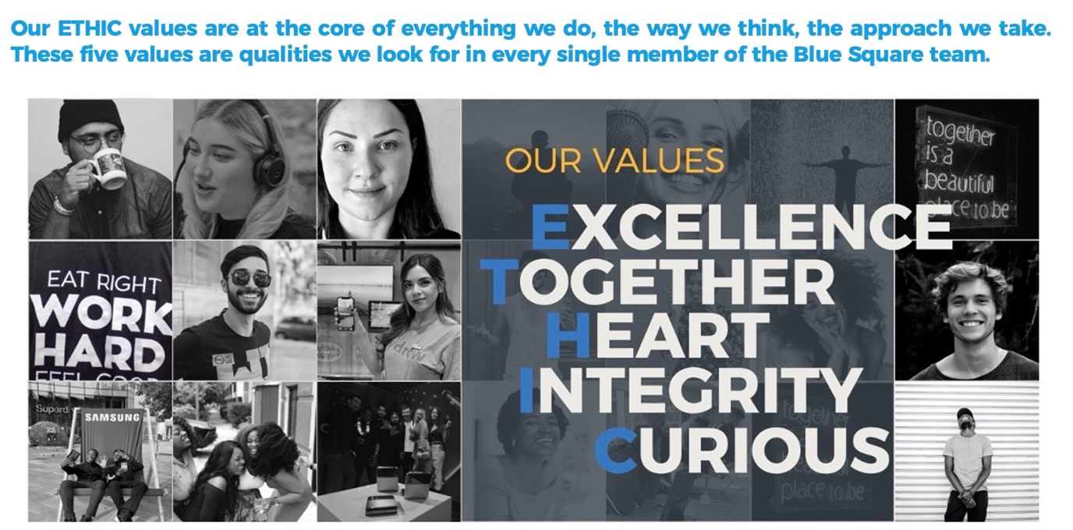

ENTER JOB TITLE HERE